# Loss Calculations

We know that Vinmin: 220 V, Vinmax: 400 V, Vout: 12 V, Pout 100 W from project description. Also, switching frequency is around 100kHz in both input voltage cases. This is known from both detailed simulations and controller features. Moreover, transformer will produce magnetic and copper losses, therefore transformer efficiency ratio will be taken as 0.9 in calculations. Output diode STPS30170DJF-TR has around 1 V forward voltage in secondary current ratings. Primary and secondary side power calculations are made as follows.

|  |  |
| --- | --- |
| $$Iout_{avg}=\frac{Pout}{Vout}, Iout_{avg}=8.333 A$$ |  |
| $$P_{diode}=V_{F}*Iout_{avg}=8.333 W$$ |  |
| $$P_{secondary}=P_{out}+P_{diode}=108.33 W$$ |  |
| $$P_{primary}=η_{transformer}=120.367 W$$ |  |

Primary side switch power loss should be calculated to reach input power. Primary and secondary peak currents should be calculated to calculate switch power loss, therefore input power will be assumed as 125 W and analytical calculations will be compared with simulation results. Also, transformer turns ratio is decided as 4.33 in magnetic design.

|  |  |
| --- | --- |
| $$V_{out}+V_{diode}=V_{in}\left(\frac{D}{1-D}\right)(\frac{N2}{N1})$$ |  |
| $$V_{in}=220 V , D=0.21;V_{in}=400 V , D=0.12$$ |  |

Primary and secondary currents have triangular shape.

|  |  |
| --- | --- |
| $$V_{in}=220 V, Dmax=0.21, Iin_{avg}=\frac{P_{in}}{V_{in}}=0.568 A$$ |  |
| $$Iin_{peak}=2*\frac{Iin_{avg}}{Dmax}=5.4 A$$ |  |
| $$V_{in}=400 V, Dmin=0.12, Iin_{avg}=\frac{P_{in}}{V_{in}}=0.3125 A$$ |  |
| $$Iin_{peak}=2*\frac{Iin_{avg}}{Dmin}=5.2 A$$ |  |

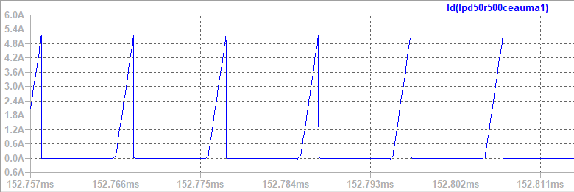

Figure MOSFET Current Waveform (Vin=220 V)

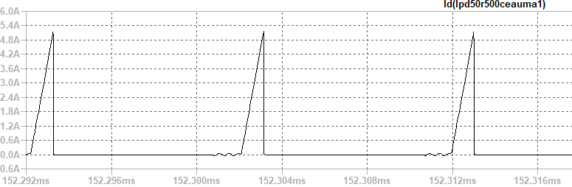

Figure MOSFET Current Waveform (Vin= 400 V)

Input current rms value is used in power loss calculation of MOSFET. It is calculated in LTspice as in figure **X.**

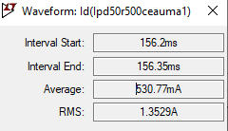

Figure Maximum value of MOSFET current

Since converter works in discontinuous conduction mode, we need dweel time to calculate secondary side peak current. Dwell time is estimated from simulations as 0.05*D*Ts.

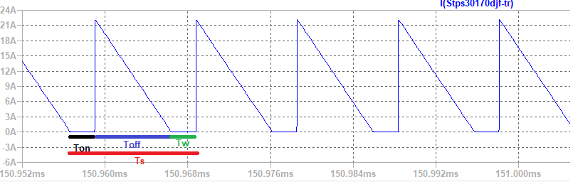

Figure Secondary Side Diode Current

|  |  |
| --- | --- |
| $$Isec_{peak(max)}=2*\frac{I{out}_{avg}}{\left(1-Ddwell-Dmax\right)}=22.52 A$$ |  |

Secondary side diode current value will be used in diode power loss, and it is calculated in LTspice.

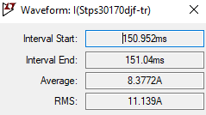

Figure Maximum value of diode current

Voltage drop on MOSFET is calculated as follows.

|  |  |
| --- | --- |
| $$V_{sw}=Vin+\frac{N1}{N2}*Vout$$ |  |

Power Calculation Table

|  |  |  |
| --- | --- | --- |
| Loss mechanism | Component | Model |
| Conduction | MOSFET | $$P_{on,M}={ Iin}^{2}R_{on,M}$$ |
| Switching | MOSFET | $$P_{sw,M}= \frac{1}{2}V_{sw}I_{in}\left(t_{rise}+t_{fall}\right)f_{sw}$$ |
| Switching – Output capacitance | MOSFET | $$P_{coss}= \frac{1}{2}V_{sw}^{2}\left(C_{DS}+C_{GD}\right)f_{sw}$$ $$P_{coss}=E_{coss}{ f}_{sw}$$ |
| Switching – Gate charge | MOSFET | $$P_{G}=Q_{g}{ V}_{gs} f_{sw}$$ |
| Switching | MOSFET Diode | $$P_{bodydiode}=\frac{1}{2}V_{sw}I_{RR}t_{RR}f_{sw}$$ |
| Conduction | Diode | $$P_{on,D}=V_{f}I_{out}$$ |
| Conduction – Copper loss | Transformer | $$P_{copper}={Iin}_{rms}^{2}R_{pri}+{Iout}_{rms}^{2}R_{sec}+{I_{third}}^{2}R_{third}$$ |
| Magnetic Loss | Transformer | $$P_{core}=a*\left(f^{x}\right)*\left(B_{op}^{y}\right)*V_{core}$$ |
| Conduction | Shunt resistor | $$P_{shunt}={Iin}_{rms}^{2}R_{shunt}$$ |
| RCD Snubber | Resistor-Diode | $$P_{on,D}=V_{f}I_{RCD} , P_{shunt}=I_{RDC,rms}^{2}R_{RCD}$$ |

Maximum RDS value is 0.5 Ω in MOSFET Datasheet, therefore the worst case is calculated in MOSFET conduction loss. $t_{rise}+t_{fall}$ time is 19ns in the worst case, therefore the worst case is calculated in MOSFET switching losses. Typical $E_{coss}=2.2 μJ$, it is taken in calculation of output capacitance power loss. Maximum Gate threshold voltage of the MOSFET is 3.5V. Total Gate charge of the MOSDET is 18.7nC. Also, body diode of the MOSFET is taken into consideration while making calculation and its related values are taken from datasheet. In the design, instead of using single diode and collecting all losses in a single diode, 5 diodes are connected in parallel, and it reduces the loss per diode also the use of heat sinks is avoided. Output diode has 0.75 V on voltage while it is conducting 1.66A per diode. Also, output diode has not reverse recovery loss since it a Schottky diode. Magnetic loss parameters are taken from Magnetics website. While calculating copper losses of the transformer, third winding is also taken into consideration, however, there is very little current on the third winding, therefore it did not affect the losses much. In the wiring design, the expected loss value was 1.5 W when the normal wiring was done first, and the copper loss decreased to 0.1 W thanks to the Litz wire. The worst case for the RCD snubber circuit occurs when the input voltage is low, that is, more current is flowing on the primary side, because the leakage inductor will store more energy. In this circuit, the resistor consumes the most power. In the worst case the RCD circuit consumes 3 Watts of power, the resistor's characteristics can meet this situation.

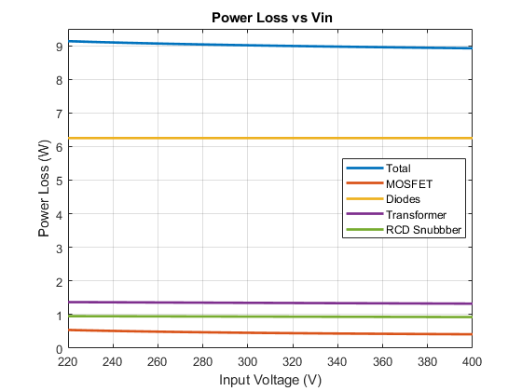

Figure X. Power Loss vs Input Voltage

According to the power calculation table, the losses with respect to the input voltage values are shown in figure X. Maximum power loss is 9.13 W, thus expected minimum efficiency of the system is %91.6. As the input voltage drops, the input current will increase since the transferred power is constant, so the losses on the primary side will increase. Thus, efficiency increases as the input voltage increases.

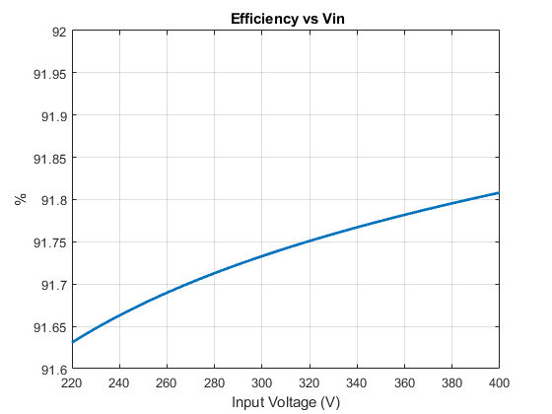

Figure Xxx. Efficiency vs Input Voltage